Retail Sales and Profit Analysis
Abstract
Retail sales and profit analysis helps explain how business revenue is generated and why profit does not always increase in the same way as sales. In retail operations, product categories, regional demand, pricing decisions, and discount strategies together influence whether a sale contributes positively to profit or leads to reduced margins. Understanding this relationship is important because a product with high sales can still produce low profit when discounts are high or margins are weak. This project examines retail business performance by studying factors such as order date, sales value, profit, discount level, product category, and region to understand how these elements affect overall performance. The analysis helps identify categories that generate stronger revenue, regions that contribute more profit, and situations where discount levels influence profitability differently across products. It also explains how sales patterns change over time and where loss-making segments appear despite strong sales activity. The study provides a broader understanding of retail performance and highlights the major factors that shape both revenue movement and profit behaviour in business operations.
- INTRODUCTION
The retail industry is one of the most dynamic and competitive sectors in the global economy, where businesses continuously strive to maximize sales while maintaining profitability. Retail operations involve multiple interconnected factors such as product categories, pricing strategies, regional demand variations, and promotional activities like discounts. While increasing sales is often considered a primary objective, it does not always guarantee higher profit. In many cases, aggressive discounting, operational inefficiencies, or low-margin products can lead to reduced profitability despite high sales volumes. This makes it essential to analyze both sales and profit together to understand true business performance.
In today’s data-driven environment, organizations generate large volumes of transactional data through their daily operations. This data contains valuable information that, when properly analyzed, can reveal patterns, trends, and hidden insights. However, raw data in its original form is often unstructured and difficult to interpret. Data analytics plays a crucial role in transforming this raw data into meaningful information that supports decision-making. By applying techniques such as data cleaning, transformation, aggregation, and visualization, businesses can better understand their performance and identify areas for improvement.
The importance of analyzing retail data lies in its ability to provide a clear picture of how different factors influence revenue and profitability. For example, analyzing sales across different product categories helps identify which products contribute most to revenue. Similarly, studying profit alongside discount levels helps uncover whether promotional strategies are beneficial or harmful to the business. Regional analysis further helps in understanding geographic performance differences, allowing businesses to tailor their strategies according to local demand. Time-based analysis, such as monthly or yearly trends, helps in identifying seasonal patterns and forecasting future performance.
Data analytics also plays a significant role in solving real-world business problems. In the context of retail, one common challenge is understanding why certain products or regions generate high sales but low profit. Another challenge is identifying loss-making transactions and determining the factors responsible for them. By using analytical tools and techniques, these problems can be systematically addressed. Structured query language (SQL) enables efficient querying and aggregation of large datasets, making it easier to extract meaningful summaries. At the same time, tools like Pandas and Matplotlib in Jupyter Notebook allow for deeper analysis, statistical exploration, and visualization of data patterns that are not easily captured through basic queries.
This project focuses on retail sales and profit analysis using a combination of SQL and Python-based tools. The dataset includes key attributes such as order date, sales, profit, discount, category, and region, which are analyzed to understand business performance. Through data preprocessing, feature engineering, and analytical techniques, the project aims to uncover relationships between sales and profit, evaluate the impact of discount strategies, and identify patterns across categories and regions. The insights derived from this analysis help in understanding how revenue is generated, why profit varies, and what factors contribute to loss-making scenarios.
Overall, this study highlights the importance of data analytics in modern retail operations. By systematically analyzing data, businesses can move beyond intuition and make informed decisions based on evidence. This not only improves operational efficiency but also enhances profitability by identifying the right balance between sales growth and cost management.
- EXISTING SYSTEM
In the existing system, retail data is primarily stored in Excel files where all transaction details such as order date, sales, profit, discount, category, and region are maintained in tabular format. The data is usually entered manually or imported from basic sources, which makes it prone to human errors such as incorrect values, missing entries, or inconsistent formatting. While Excel provides a simple and accessible way to store data, it is mainly used for basic record keeping rather than advanced analysis.
The existing approach focuses mostly on viewing and managing records rather than extracting meaningful insights. Users can sort or filter data in Excel, but performing deeper analysis such as identifying patterns, correlations, or trends requires significant manual effort. Generating reports often involves repetitive tasks and complex formulas, which can be time-consuming and difficult to maintain, especially as the dataset grows larger.
Another limitation of the existing system is the lack of structured querying and automation. Since the data is not stored in a relational database, it becomes challenging to perform efficient aggregations, comparisons, and multi-level analysis. As a result, important business questions, such as understanding profit behavior across regions or the impact of discounts on profitability, are not easily answered.
Overall, the existing system is suitable for basic data storage and viewing but lacks the capability to perform efficient, scalable, and insightful data analysis required for informed decision-making in retail operations.
- DISADVANTAGES OF EXISTING SYSTEM
The existing system of managing retail data using Excel and manual processes has several limitations that affect efficiency, accuracy, and decision-making. These disadvantages highlight the need for a more structured and analytical approach.
- Human errors
Manual data entry increases the chances of errors such as incorrect values, missing records, duplicate entries, and inconsistent formatting. Even small mistakes in sales or profit values can lead to incorrect analysis and misleading conclusions. Since there is no automated validation, identifying and correcting these errors becomes difficult and time-consuming.
- Time-consuming process
Working with large Excel files requires significant manual effort for tasks such as sorting, filtering, and applying formulas. Generating reports or summaries involves repetitive steps that consume a lot of time. As the dataset grows, the performance of Excel decreases, making operations slower and less efficient.
- No proper analytical capability
The existing system is mainly used for storing and viewing data rather than analyzing it. While Excel provides basic functions, it is not suitable for advanced analysis such as identifying patterns, correlations, trends, or relationships between variables. Important insights like the impact of discounts on profit or category-wise performance are difficult to derive effectively.
- Difficult to manage large data
As the volume of retail data increases, managing it in Excel becomes challenging. Large files can become slow, unresponsive, and prone to crashes. Handling multiple sheets or files leads to confusion and increases the risk of data inconsistency. There is no centralized system to manage and organize large-scale data efficiently.
- Lack of automation
Most operations in the existing system require manual intervention. Tasks such as updating data, generating reports, and performing calculations are not automated, which increases workload and reduces productivity. This also leads to delays in obtaining results and insights.
- Limited scalability
The system is not designed to handle growing data requirements. As business operations expand and data volume increases, the existing approach becomes inefficient and difficult to scale. It does not support advanced tools or integration with analytical systems.
- Poor decision-making support
Since the system lacks proper analysis and insight generation, it does not effectively support business decision-making. Managers and stakeholders rely on basic summaries rather than detailed insights, which can lead to incorrect or incomplete decisions.
Overall, the existing system is inefficient for handling modern retail data requirements and fails to provide the analytical capabilities needed for accurate and timely decision-making.
- PROPOSED SYSTEM
The proposed system is designed to overcome the limitations of the existing Excel-based approach by introducing a structured and efficient data analytics workflow. In this system, retail data is processed through multiple stages, starting from raw data storage to advanced analysis and result generation. The overall flow of the system follows a clear pipeline: Excel or CSV data is first loaded into a SQL database, where structured querying is performed, and then further processed using Python for deeper analysis and visualization.
The process begins with data collection, where the retail dataset is stored in Excel or CSV format. This dataset contains important attributes such as order date, sales, profit, discount, category, and region. Instead of directly analyzing this raw data in Excel, it is imported into a MySQL database. Storing data in a database improves organization, ensures better data integrity, and allows efficient handling of large datasets.
Once the data is stored in the SQL database, query analysis is performed using structured query language. SQL plays a crucial role in extracting meaningful information from the dataset. It is used to perform operations such as filtering records, grouping data, calculating aggregates like total sales and profit, and identifying patterns across categories and regions. Queries such as category-wise sales, region-wise profit, monthly trends, and discount-based analysis help in summarizing large volumes of data into understandable results. SQL provides a fast and efficient way to retrieve specific insights without manually scanning the entire dataset.
After obtaining structured outputs from SQL, the data is further processed using Python in Jupyter Notebook. Python, along with libraries like Pandas and Matplotlib, enhances the analytical capabilities of the system. Pandas is used for data cleaning, transformation, and feature engineering. New columns such as year, month, weekday, profit margin, discount level, profit flag, and sales segment are created to enrich the dataset and enable deeper analysis. These derived features help in understanding complex relationships within the data.
Python also allows advanced analytical operations that are difficult to perform using SQL alone. This includes correlation analysis, pivot tables, statistical summaries, and detailed segmentation of data. Matplotlib is used to create visualizations such as box plots, which help in identifying trends, variations, and outliers in profit and sales. These visual representations make it easier to interpret data and communicate insights effectively.
The final stage of the proposed system is result generation, where insights obtained from both SQL queries and Python analysis are combined. The system provides a comprehensive understanding of retail performance by highlighting key factors affecting sales and profitability. It helps in identifying loss-making scenarios, understanding the impact of discounts, and evaluating performance across categories and regions.
Overall, the proposed system offers a structured, efficient, and scalable approach to retail data analysis. By integrating SQL for data querying and Python for advanced processing, it transforms raw data into meaningful insights that support better decision-making and improve business performance.
- ADVANTAGES OF PROPOSED SYSTEM
The proposed system offers significant improvements over the traditional Excel-based approach by introducing a structured, efficient, and scalable method for data analysis. By integrating SQL for data storage and querying with Python for advanced processing, the system enhances both performance and analytical capabilities. The following advantages highlight the benefits of the proposed system in detail.
- Faster analysis
The proposed system significantly reduces the time required to analyze data. SQL enables quick retrieval of required information through structured queries, even when dealing with large datasets. Instead of manually filtering and calculating values in Excel, queries can instantly generate summaries such as total sales, profit by category, or monthly trends. Additionally, Python automates data processing tasks such as cleaning, transformation, and feature creation, which further speeds up the overall workflow. This results in quicker insights and faster decision-making.
- Accurate results
Accuracy is greatly improved in the proposed system due to reduced manual intervention. Data processing steps such as type conversion, missing value handling, and feature engineering are performed programmatically using Pandas, minimizing the chances of human error. SQL queries ensure precise calculations through well-defined aggregation functions. Since the same logic can be reused consistently, the results remain reliable and reproducible. This leads to more trustworthy analysis and better business conclusions.
- Organized data management
Storing data in a MySQL database provides a well-structured and organized environment compared to scattered Excel files. The data is maintained in a centralized system, making it easier to access, update, and manage. Tables, columns, and data types are clearly defined, ensuring consistency across the dataset. This organization also supports better scalability, allowing the system to handle increasing volumes of data without performance issues. It eliminates redundancy and improves overall data integrity.
- Easy query-based insights
The use of SQL allows users to easily extract insights using simple and readable queries. Complex questions such as identifying loss-making regions, analyzing discount impact on profit, or comparing category performance can be answered efficiently using SQL statements. Grouping, filtering, and aggregation operations simplify the analysis process. This makes it easier for users to explore the data and generate meaningful insights without performing complicated manual operations.
- Enhanced analytical capability
The integration of Python with Pandas and Matplotlib enables deeper analysis beyond basic querying. Advanced operations such as correlation analysis, pivot tables, and statistical summaries provide a more detailed understanding of the data. Visualization tools help in identifying trends, patterns, and outliers, which are not easily visible in raw data. This improves the overall analytical depth of the system.
- Better decision-making support
The proposed system provides clear, data-driven insights that support effective decision-making. By analyzing factors such as sales trends, profit distribution, discount impact, and regional performance, the system helps businesses understand what strategies are working and where improvements are needed. This leads to more informed and strategic business decisions.
- Scalability and flexibility
The system is capable of handling large and growing datasets efficiently. SQL databases are designed for scalability, and Python provides flexibility for implementing various analytical techniques. New features, queries, or analysis methods can be easily added without disrupting the existing workflow. This makes the system adaptable to changing business requirements.
Overall, the proposed system provides a comprehensive solution for retail data analysis by improving speed, accuracy, organization, and analytical depth, making it highly suitable for real-world business applications.
- INTRODUCTION TO APPLICATION
The application developed in this project is a data analytics system designed to analyze retail sales and profit data in an efficient and structured manner. The system focuses on transforming raw transactional data into meaningful insights that help in understanding business performance. It performs operations such as data storage, querying, processing, and visualization to provide a complete analytical workflow. The main objective of the application is to identify patterns in sales, evaluate profitability, and understand how different factors such as discount levels, product categories, and regions influence overall business outcomes.
The user interacts with the system through two main components: SQL and Python. In the SQL environment, the user writes queries to retrieve and summarize data stored in the MySQL database. These queries allow the user to perform operations such as calculating total sales, analyzing profit by category or region, identifying loss-making transactions, and observing monthly trends. The results generated from SQL queries provide structured and aggregated outputs that are easy to interpret.
In the Python environment, specifically within Jupyter Notebook, the user performs further data processing and analysis using Pandas and Matplotlib. The user can clean the data, create new features, and perform advanced analytical operations that go beyond basic querying. Python also allows the user to generate visualizations such as box plots, which help in identifying patterns, variations, and outliers in the data. This interaction enables a deeper understanding of the dataset and supports more detailed analysis.
The flow of data within the application follows a systematic process. Initially, the raw dataset is collected in Excel or CSV format. This data is then imported into the MySQL database, where it is structured into tables for efficient storage and management. SQL queries are applied to extract relevant information and generate intermediate results. These results are then used in Python for further processing, feature engineering, and visualization. Finally, the processed outputs are analyzed to derive insights and conclusions.
Overall, the application provides a smooth and organized workflow for retail data analysis. It allows users to move from raw data to meaningful insights through a combination of structured querying and advanced analytical processing, making it a practical tool for understanding and improving business performance.
- BLOCK DIAGRAM
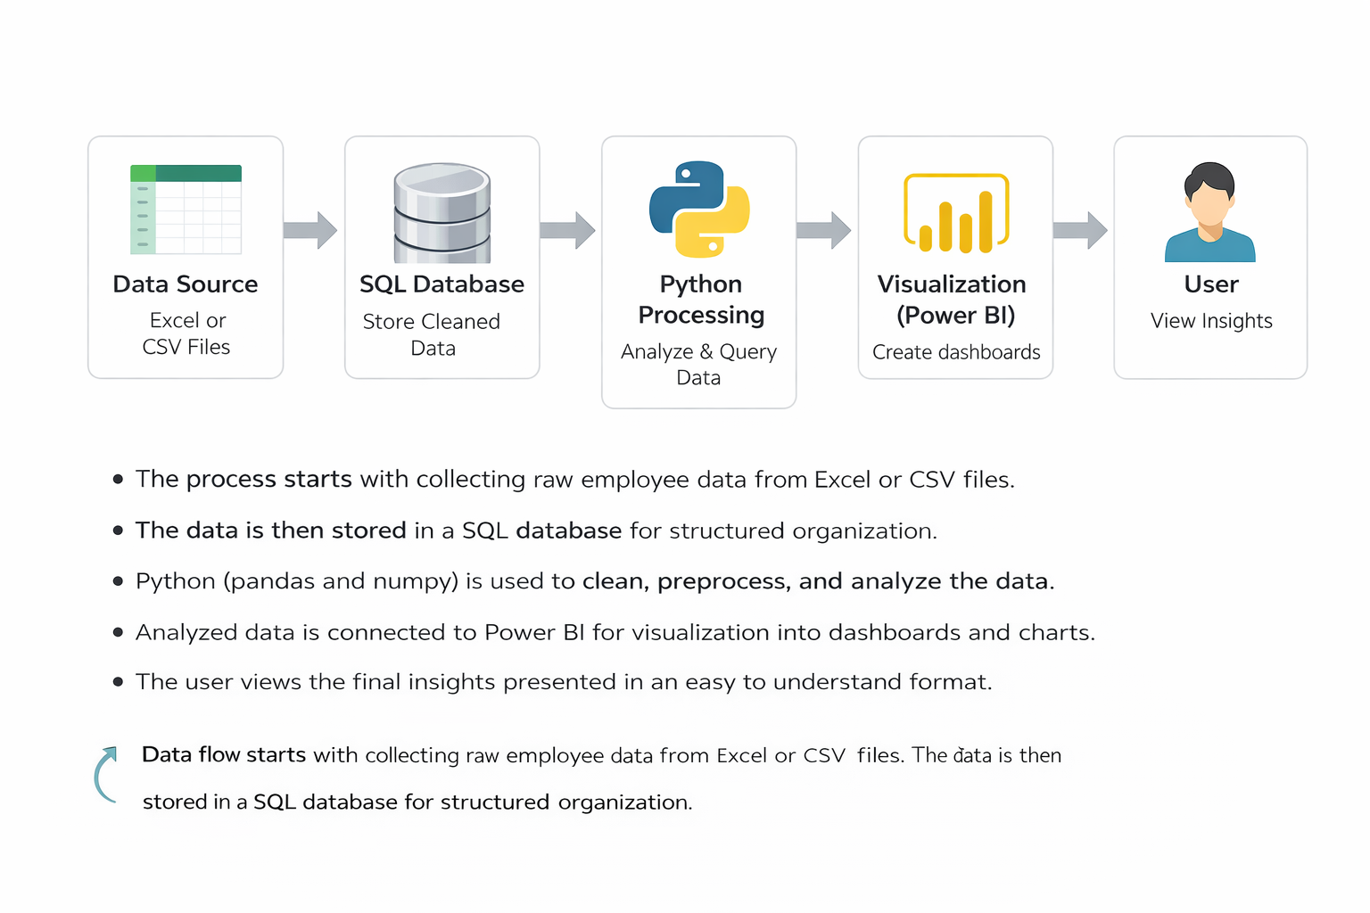
Data Source → Python Processing → SQL Database → User
The block diagram represents the flow of data in the retail sales and profit analysis system. It shows how raw data is processed, stored, and analyzed before presenting meaningful results to the user.
Data Source
The data source is the starting point of the system where raw retail data is collected. In this project, the dataset is available in Excel or CSV format and contains key attributes such as order date, sales, profit, discount, category, and region. This data is unprocessed and may contain inconsistencies, making it necessary to clean and prepare it before analysis.
Python Processing
In this stage, Python is used to clean and transform the raw data using Pandas in Jupyter Notebook. The data is checked for missing values, incorrect formats, and inconsistencies. Column names are standardized, and the order date is converted into datetime format. Feature engineering is performed by creating new columns such as year, month, weekday, profit margin, discount level, profit flag, and sales segment. This step ensures that the data becomes structured, enriched, and ready for efficient analysis.
SQL Database
After processing in Python, the cleaned and transformed data is stored in a MySQL database. This allows the data to be organized in a structured format for efficient storage and retrieval. SQL is used to perform queries such as aggregating sales and profit, analyzing category and region performance, and identifying trends. The database enables fast and efficient handling of large datasets and supports structured analytical operations.
User
The final stage represents the user who interacts with the system to obtain insights. The user executes SQL queries to retrieve summarized data and uses Python outputs for deeper analysis and visualization. Based on the results, the user can understand business performance, identify patterns, and make informed decisions. The system provides clear and meaningful outputs that help the user interpret complex data easily.
This block diagram explains how data flows from raw input through processing and storage stages, ultimately delivering useful insights to the user.

- DATA ANALYTICS SECTION
9.1 Overview
Data analytics is the process of examining raw data to extract useful information, identify patterns, and support decision-making. It involves collecting data, cleaning it, transforming it into a structured format, and analyzing it using various techniques. The main goal of data analytics is to convert large volumes of data into meaningful insights that can help in understanding trends and improving performance.
In simple terms, data analytics helps answer important questions such as what is happening in the data, why it is happening, and how it can be improved. By analyzing data, businesses can identify patterns such as increasing sales trends, declining profits, or the impact of discounts on revenue. This makes it easier to understand business behavior and take appropriate actions.
In this project, data analytics is applied to retail sales and profit data. The dataset is analyzed to understand how different factors such as product categories, regions, discounts, and time influence overall performance. The process begins with cleaning and preparing the data using Python, followed by structured querying using SQL to extract summaries and trends. Further analysis is performed using Pandas and visualizations are created using Matplotlib to better understand patterns and variations.
Data analytics plays an important role in improving business efficiency by providing clear and data-driven insights. Instead of relying on assumptions, decisions can be made based on actual data. This helps in identifying profitable areas, reducing losses, and optimizing strategies such as pricing and discount policies. Overall, data analytics provides a systematic approach to understanding data and making better decisions in real-world applications.
9.2 Data Description
The dataset used in this project contains retail transaction data that helps in analyzing sales and profit performance. It includes various columns representing order details, financial values, and categorical information. Each column plays an important role in understanding different aspects of the business.
Columns
The dataset consists of the following columns:
Order Date
This column represents the date on which the order was placed. It is used to analyze time-based trends such as monthly or yearly sales performance.
Sales
This column indicates the total revenue generated from each transaction. It helps in understanding how much income is being generated from sales.
Profit
This column shows the profit earned or loss incurred from each transaction. It is a key metric used to evaluate business performance.
Discount
This column represents the discount applied to each order. It is important for analyzing how pricing strategies affect profitability.
Category
This column defines the type of product sold, such as furniture, office supplies, or technology. It helps in comparing performance across different product groups.
Region
This column indicates the geographical area where the order was placed. It is used to analyze regional performance and demand differences.
Year
This column is derived from the order date and represents the year of the transaction. It is used for yearly trend analysis.
Month
This column is also derived from the order date and represents the month of the transaction. It helps in identifying seasonal patterns.
Day
This column represents the day of the month when the order was placed. It is useful for more detailed time-based analysis.
Weekday
This column indicates the day of the week on which the order occurred. It helps in analyzing sales performance across different days.
Profit Margin
This is a derived column calculated as profit divided by sales. It helps in understanding how efficiently sales are converted into profit.
Discount Level
This column categorizes discounts into levels such as low, medium, and high. It simplifies the analysis of discount impact on profit.
Profit Flag
This column classifies each transaction as either profit or loss based on the profit value. It helps in identifying loss-making transactions.
Sales Segment
This column groups sales into categories such as low, medium, high, and very high. It helps in analyzing performance based on sales ranges.
Data Types
The dataset contains different types of data:
Date type is used for the order date column to support time-based analysis.
Numeric types such as integer and float are used for columns like sales, profit, discount, and profit margin to perform calculations and aggregations.
Categorical or string types are used for columns like category, region, discount level, profit flag, and sales segment to represent grouped or descriptive data.
Purpose
The purpose of this dataset is to analyze retail business performance by examining the relationship between sales and profit. It helps in identifying how different factors such as discounts, product categories, regions, and time influence profitability. The dataset is used to perform both SQL-based querying and Python-based analysis, enabling the extraction of meaningful insights that support better decision-making.
9.3 Data Preprocessing
Data preprocessing is an essential step in the data analytics process that prepares raw data for analysis. In this project, preprocessing is performed using Python in Jupyter Notebook with the help of the Pandas library. The goal of this stage is to ensure that the dataset is clean, consistent, and properly structured so that accurate and meaningful analysis can be performed.
Cleaning
Data cleaning involves identifying and correcting errors or inconsistencies present in the dataset. Initially, the dataset is examined to understand its structure, column names, and data types. Column names are standardized by converting them into lowercase and replacing spaces with underscores to maintain uniformity and avoid issues during processing. Duplicate records, if any, are checked and removed to prevent incorrect aggregation results. Unnecessary columns or irrelevant data are also eliminated to keep the dataset focused and efficient for analysis. This step ensures that the dataset is reliable and ready for further processing.
Missing Values
Handling missing values is an important part of preprocessing, as incomplete data can affect the accuracy of analysis. The dataset is checked for null or missing values in each column. If missing values are found in critical columns such as sales or profit, appropriate actions are taken, such as removing those records or replacing them with suitable values based on the context. For categorical columns, missing values may be filled with a default category if necessary. Proper handling of missing values ensures that the dataset remains complete and does not introduce bias or errors in the results.
Formatting
Formatting ensures that all data is in the correct and consistent format required for analysis. The order date column is converted into a datetime format to enable time-based operations such as extracting year, month, and weekday. Numeric columns such as sales, profit, and discount are verified to ensure they are in the correct numerical format for calculations. Categorical columns such as category and region are checked for consistency in naming to avoid duplication caused by spelling differences or case sensitivity. This step ensures that all data types are appropriate and consistent, making the dataset suitable for efficient analysis.
Overall, data preprocessing improves the quality of the dataset and lays a strong foundation for accurate analysis. By cleaning the data, handling missing values, and ensuring proper formatting, the dataset becomes well-structured and ready for generating meaningful insights.
9.4 Exploratory Data Analysis
Exploratory Data Analysis is the process of examining the dataset to understand its structure, identify trends, detect patterns, and derive initial observations before performing detailed analysis. In this project, exploratory analysis is carried out using Pandas and Matplotlib to gain a clear understanding of how sales and profit behave across different factors such as time, category, region, and discount levels.
Trends
Trend analysis helps in understanding how sales and profit change over time. By analyzing data based on year and month, it becomes possible to identify whether sales are increasing, decreasing, or remaining stable. Seasonal variations can also be observed, where certain months show higher sales due to demand fluctuations. Similarly, profit trends reveal whether increased sales are contributing to higher profitability or not. In this project, it is observed that sales may show consistent growth over time, but profit does not always follow the same pattern, indicating the influence of other factors such as discounts and cost structures.
Patterns
Patterns in the data help in identifying relationships between different variables. One important pattern observed in this project is the relationship between discount and profit. Higher discount levels tend to reduce profit margins and often lead to losses, even when sales are high. Another pattern is seen across product categories, where some categories generate higher sales but lower profit, while others maintain better profit margins. Regional patterns also emerge, showing how different geographical areas contribute differently to sales and profit. These patterns help in understanding which areas of the business are performing well and which require improvement.
Observations
Several key observations can be derived from the exploratory analysis. A significant number of transactions result in low or negative profit, indicating the presence of loss-making sales. Extreme values or outliers are observed in profit distribution, showing that some transactions incur very high losses compared to the gains from profitable transactions. The impact of discount levels is clearly visible, with higher discounts leading to increased losses. Additionally, sales distribution across weekdays shows variation, indicating that certain days perform better than others. These observations provide a deeper understanding of the dataset and highlight critical factors affecting business performance.
Overall, exploratory data analysis helps in uncovering hidden insights within the data and provides a strong foundation for further analysis. By identifying trends, patterns, and observations, it becomes easier to understand the behavior of sales and profit and to make informed decisions based on data.
9.5 TOOLS USED
The following tools are used in this project to perform data processing, analysis, storage, and visualization. Each tool plays a specific role in the overall workflow.
1. Python
Python is the core programming tool used for implementing the entire data analysis process. It is used to write scripts for data cleaning, transformation, and analysis.

2. Jupyter Notebook
Jupyter Notebook is used as the development tool where Python code is written and executed. It provides an interactive environment to run code step-by-step and view outputs instantly.

3. Pandas
Pandas is used for data manipulation and handling structured data. It helps in reading datasets, filtering data, grouping values, and creating new columns required for analysis.

4. Matplotlib
Matplotlib is used for creating visualizations such as bar charts and histograms. It helps in understanding patterns and trends in the dataset during analysis.

5. MySQL
MySQL is used as the database tool for storing and managing the dataset. It allows execution of SQL queries to retrieve and analyze data efficiently.

10. SOFTWARE REQUIREMENTS
Software requirements refer to the platforms and environments needed to develop, run, and execute the project. These provide the base setup where all tools and libraries function.
1. Operating System
The project can run on operating systems such as Windows, macOS, or Linux. In this project, a Windows environment is typically used, which supports Python, Jupyter Notebook, and other required tools. The operating system manages file handling, software installation, and execution of programs.

2. Python Environment
Python is required as the core programming language. A proper Python environment must be installed to execute scripts and run data analysis.
In this project:
- Python is used to write all preprocessing and analysis logic
- It acts as the base for libraries like pandas, NumPy, and matplotlib
- Version compatibility is important to ensure smooth execution

3. Jupyter Notebook Environment
Jupyter Notebook is required as the development platform for writing and running code interactively.
In this project:
- It provides an interface to execute Python code step-by-step
- It allows combining code, outputs, and explanations in one place
- It helps in testing and debugging during development

4. Library Support (Python Packages)
The system requires installation of essential Python libraries. These are not standalone software but part of the Python environment.
Required libraries include:
- pandas for data handling
- NumPy for numerical operations
- matplotlib for visualization
These libraries must be installed using package managers such as pip before running the project.

5. Database Software (MySQL)
MySQL is used as the database system for storing and querying structured data.
In this project:
- It stores insurance dataset in table format
- SQL queries are executed to filter and analyze data
- It supports structured data management and retrieval

7. Web Browser
A web browser such as Chrome or Edge is required to access Jupyter Notebook and Power BI interfaces. It provides the interface for interacting with dashboards and notebooks.

11. HARDWARE REQUIREMENTS
1. Processor
- Minimum Intel Core i3 or equivalent
- Recommended Intel Core i5 or higher
The processor is responsible for executing all operations in the system. A basic processor like i3 can handle small datasets and simple analysis. However, for better performance, especially when running multiple tools such as Jupyter Notebook and Power BI together, a higher processor like i5 or above is preferred. A faster processor reduces computation time and improves overall system responsiveness.
2. RAM
- Minimum 4 GB RAM
- Recommended 8 GB or more
RAM is used to temporarily store data during execution. A minimum of 4 GB is sufficient for basic tasks, but it may cause slow performance when handling larger datasets. Using 8 GB or more allows smoother multitasking and faster data processing. Higher RAM ensures that the system does not lag when multiple applications are running.
3. Storage
- Minimum 256 GB storage
- Recommended SSD storage
Storage is required to install software and store datasets and project files. A minimum of 256 GB is needed for proper functioning. Solid State Drives are recommended over traditional hard drives because they provide faster data access and improve system speed. Faster storage reduces loading time and enhances performance.
4. Operating System
- Windows, macOS, or Linux supported
- Recommended 64-bit Windows 10 or above
The operating system acts as the base platform for running all tools and applications. A 64-bit system is recommended for better compatibility and performance. Windows 10 or higher is commonly used as it supports all required software such as Python, MySQL, and Power BI efficiently.
Summary
The hardware components play an important role in ensuring smooth execution of the project. A good processor, sufficient RAM, fast storage, and a compatible operating system together provide a stable and efficient working environment.

Why These Hardware Requirements Are Sufficient for the Project
The specified hardware configuration is sufficient for this project because the nature of the work involves moderate data processing, analysis, and visualization, rather than extremely heavy computations or large-scale distributed systems. Each component supports the project requirements effectively.
Processor Sufficiency
The project mainly uses Python, Jupyter Notebook, SQL queries, and Power BI dashboards. These tasks involve data manipulation, filtering, grouping, and visualization, which do not require very high-end processing power. A processor like Intel Core i3 can handle these operations without major issues. However, using an i5 or higher ensures faster execution when performing multiple operations or running several tools at the same time. Since the dataset is of manageable size and not extremely large, this level of processing power is sufficient.
RAM Sufficiency
The dataset used in this project is structured and moderate in size, meaning it can easily fit into memory. A minimum of 4 GB RAM is enough to load and process such data in pandas and NumPy. However, when using tools like Power BI along with Jupyter Notebook, additional memory is beneficial. With 8 GB RAM, the system can handle multitasking smoothly, ensuring that data analysis, visualization, and querying operations run without lag. Therefore, this RAM range is adequate for efficient performance.
Storage Sufficiency
The project requires storage for datasets, software installations, and output files such as reports and dashboards. The data size is not extremely large, so 256 GB storage is more than enough to accommodate all files. Using SSD storage further improves performance by reducing loading times and speeding up file access. This ensures quick opening of datasets, faster execution of notebooks, and smooth operation of Power BI dashboards.
Operating System Sufficiency
The project tools such as Python, Jupyter Notebook, MySQL, and Power BI are fully compatible with modern operating systems like Windows, macOS, and Linux. A 64-bit operating system ensures better memory utilization and supports all required software efficiently. Windows 10 or above is commonly used and provides a stable environment for running all components without compatibility issues. Therefore, the operating system requirement is sufficient for seamless execution.
Overall Justification
The project does not involve heavy machine learning models, real-time big data processing, or high-performance computing tasks. Instead, it focuses on structured data analysis, visualization, and dashboard creation. The specified hardware is capable of handling these operations efficiently without unnecessary resource usage. It provides a balanced configuration that ensures smooth performance, cost-effectiveness, and practical usability for real-world implementation.
- METHODOLOGY
The methodology of this project follows a systematic and structured approach to analyze retail sales and profit data. Each step in the process is designed to transform raw data into meaningful insights using Python and SQL. The methodology ensures that the analysis is accurate, efficient, and easy to interpret.
Data Collection
The first step involves collecting the dataset, which is available in Excel or CSV format. The dataset contains important retail transaction details such as order date, sales, profit, discount, category, and region. This raw data serves as the foundation for the entire analysis. At this stage, the data is unprocessed and may contain inconsistencies or missing values.
Data Cleaning (Python)
The collected data is then processed using Python in Jupyter Notebook with the help of the Pandas library. The dataset is examined to understand its structure and data types. Column names are standardized by converting them into lowercase and replacing spaces with underscores. The order date column is converted into datetime format to enable time-based analysis. Missing values are identified and handled appropriately to ensure data completeness. Additional feature engineering is performed by creating new columns such as year, month, weekday, profit margin, discount level, profit flag, and sales segment. This step ensures that the data becomes clean, consistent, and enriched for analysis.
Data Storage (SQL)
After cleaning and transformation, the processed dataset is stored in a MySQL database. Storing data in a relational database provides better organization, efficient data management, and faster access. The data is structured into tables with clearly defined columns and data types. This step enables efficient handling of large datasets and prepares the data for structured querying.
Query-based Analysis
SQL is used to perform analytical queries on the stored data. Various queries are written to extract meaningful information such as total sales and profit, category-wise performance, region-wise analysis, monthly sales trends, and discount impact on profit. SQL enables grouping, filtering, and aggregation operations that help in summarizing large amounts of data into understandable results. This step provides the core analytical outputs required for the project.
Result Interpretation
The final step involves interpreting the results obtained from SQL queries and Python analysis. The outputs are analyzed to identify trends, patterns, and key insights related to sales and profit. Observations such as the impact of discounts on profitability, variation across categories and regions, and the presence of loss-making transactions are derived. These insights help in understanding business performance and support better decision-making.
Overall, the methodology ensures a clear and logical flow from raw data to meaningful insights, combining the strengths of Python for data processing and SQL for efficient querying and analysis.
- UML DIAGRAMS
Use Case Diagram
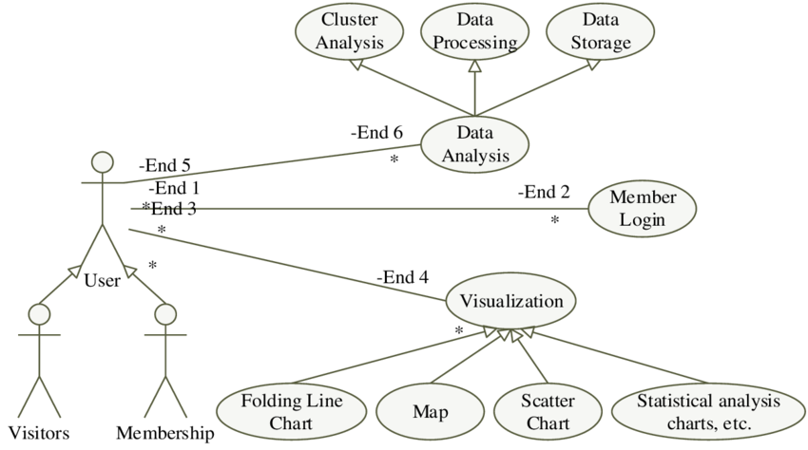

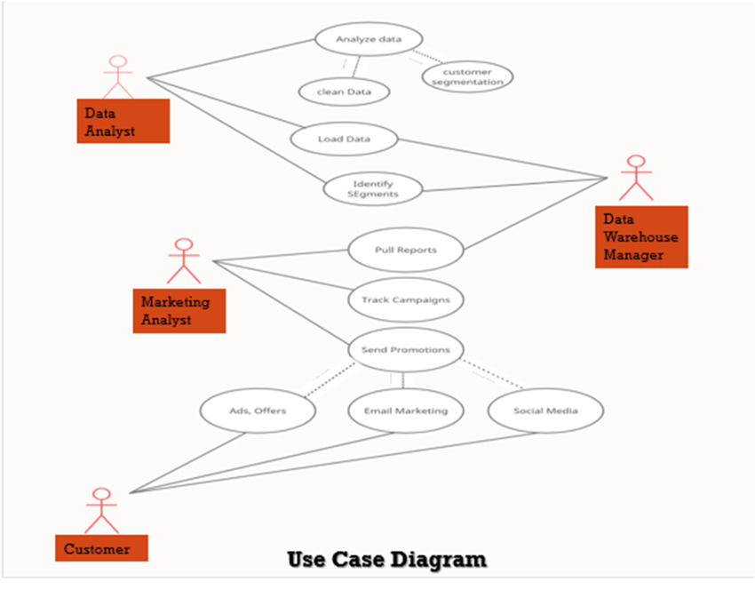
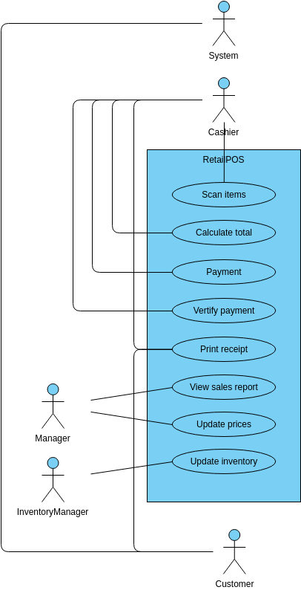
The use case diagram represents how the user interacts with the system. In this project, the primary actor is the user who performs actions such as loading data, executing SQL queries, processing data in Python, and viewing results. The system allows the user to analyze sales and profit, check trends, and generate insights. This diagram shows that the system is user-driven, where the user initiates queries and analysis to obtain meaningful outputs.
Class Diagram
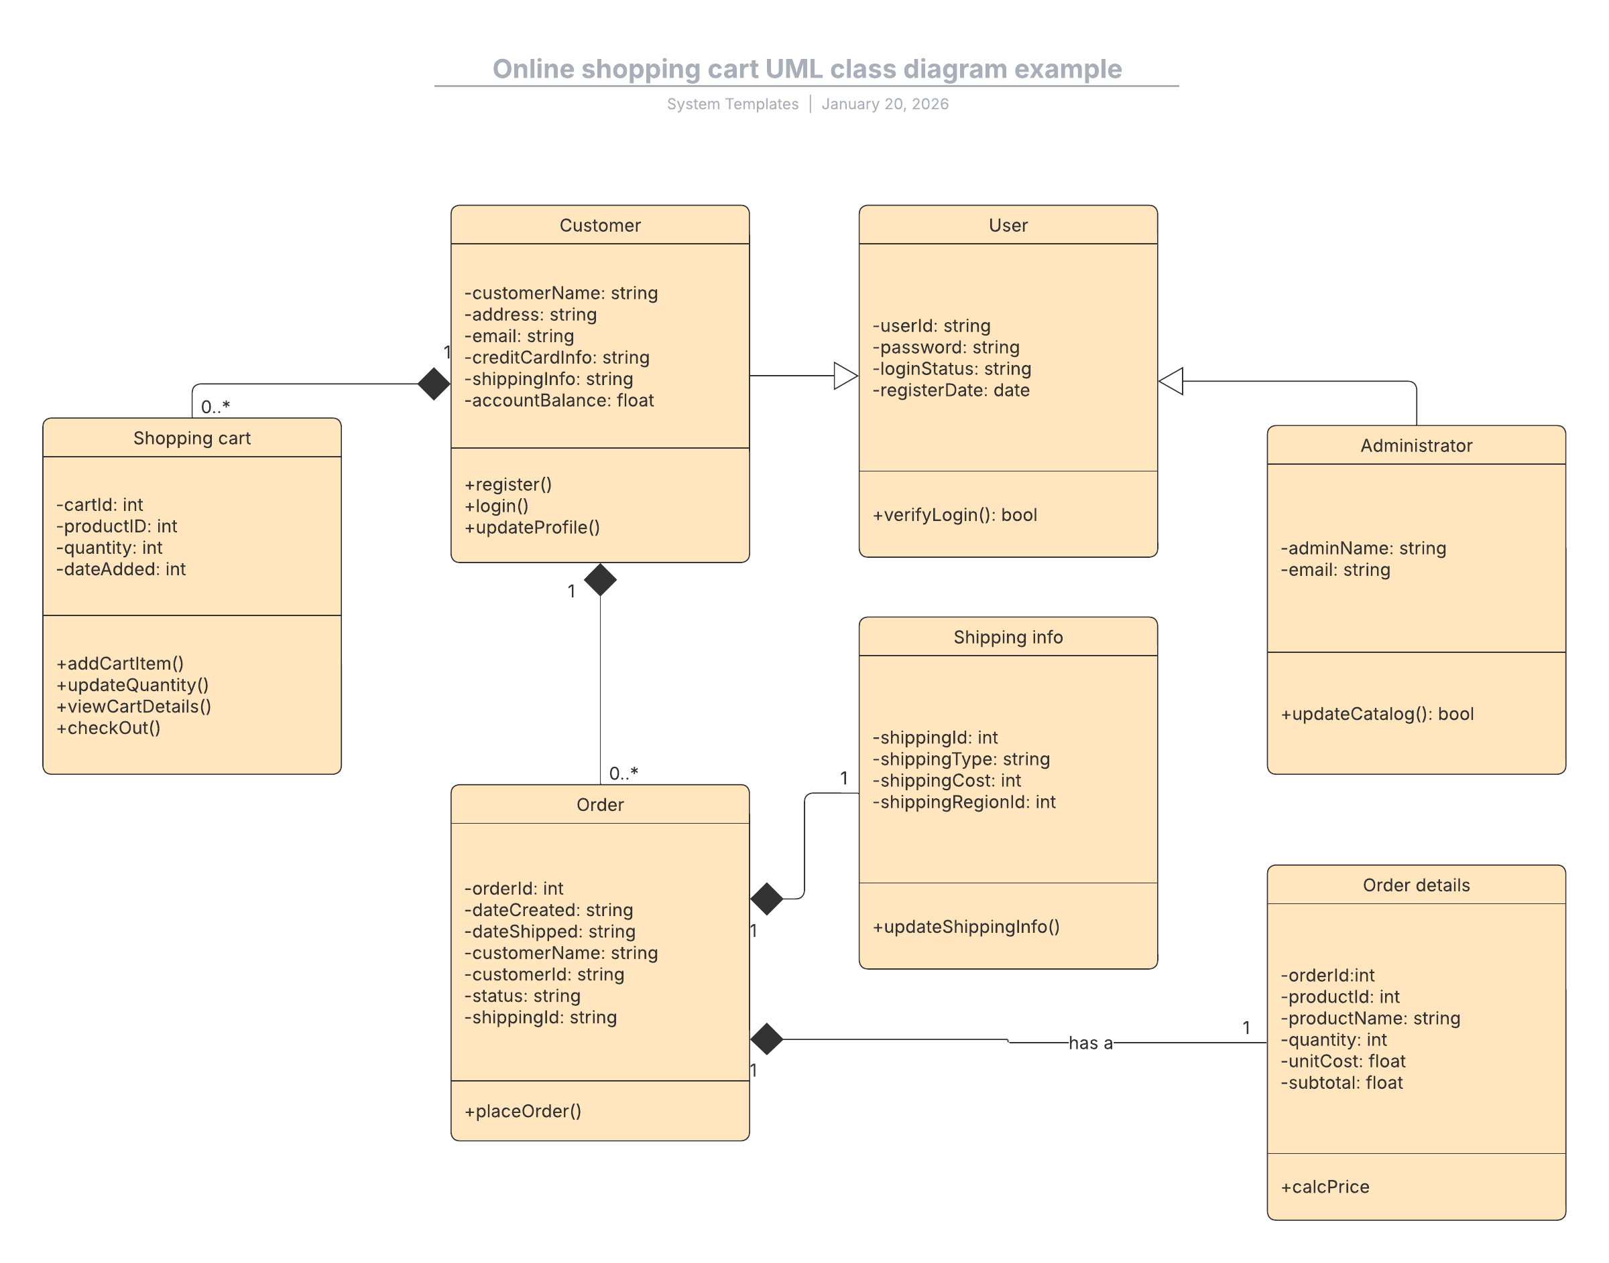
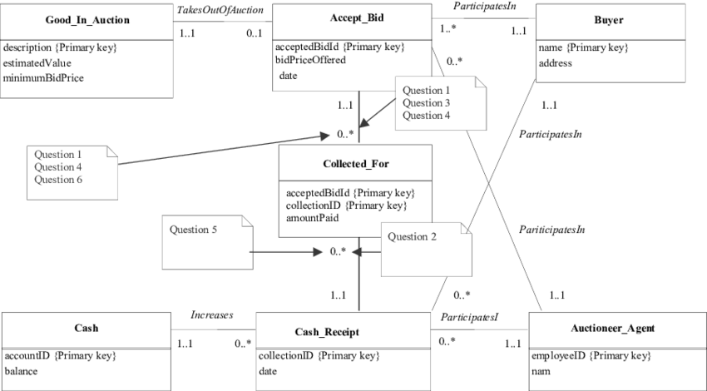
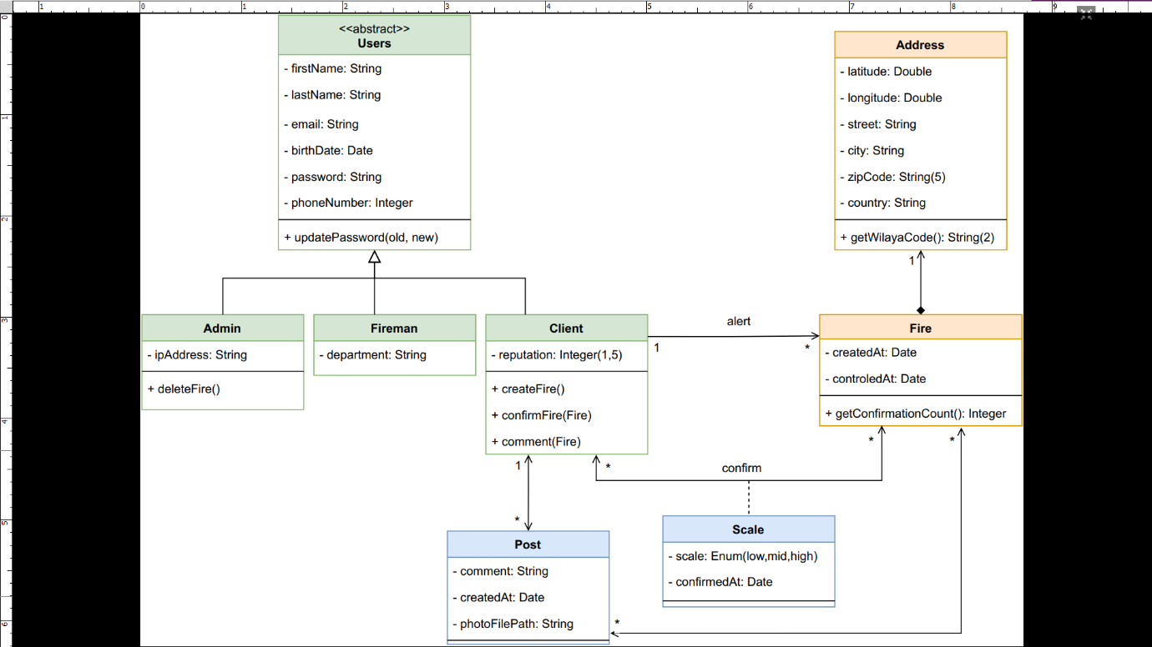

The class diagram represents the structure of the data used in the system. In this project, the main class is the retail dataset, which includes attributes such as order date, sales, profit, discount, category, and region. Additional derived attributes like year, month, profit margin, and discount level are also included. This diagram helps in understanding how data is organized and how different attributes are related within the dataset.
Sequence Diagram
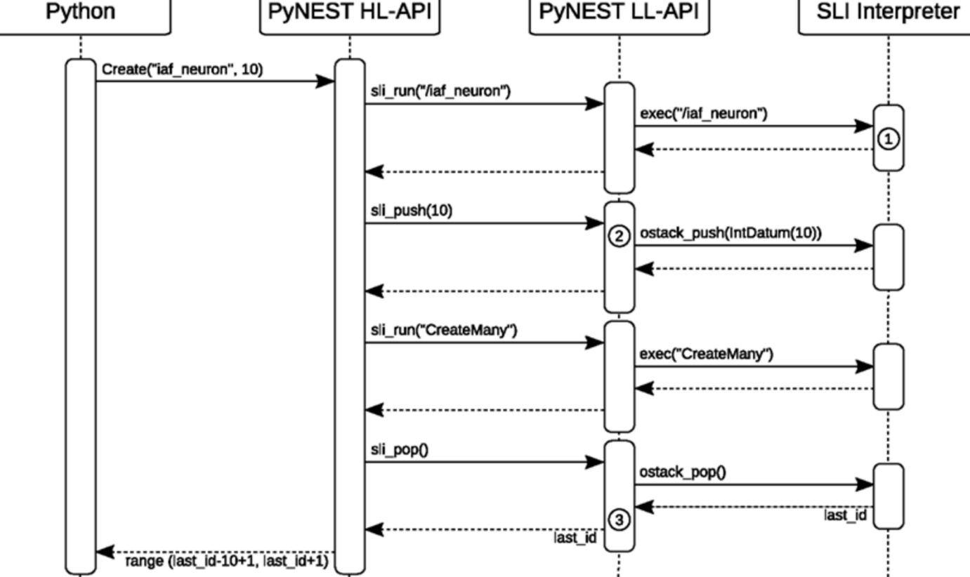
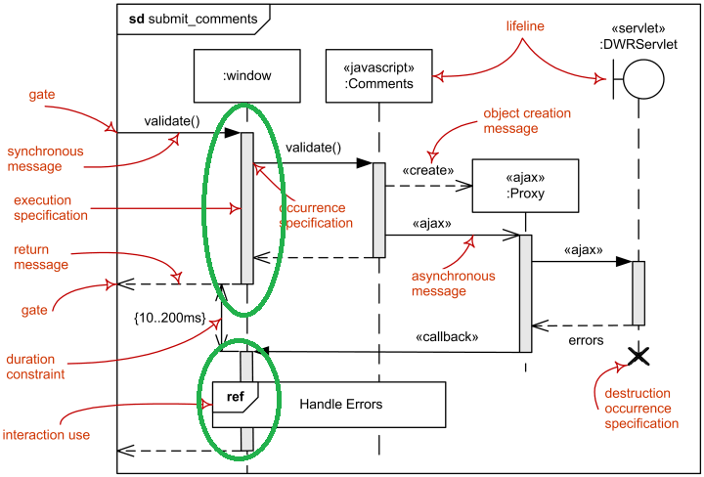
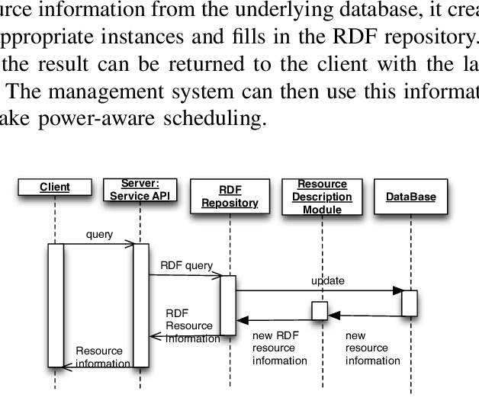
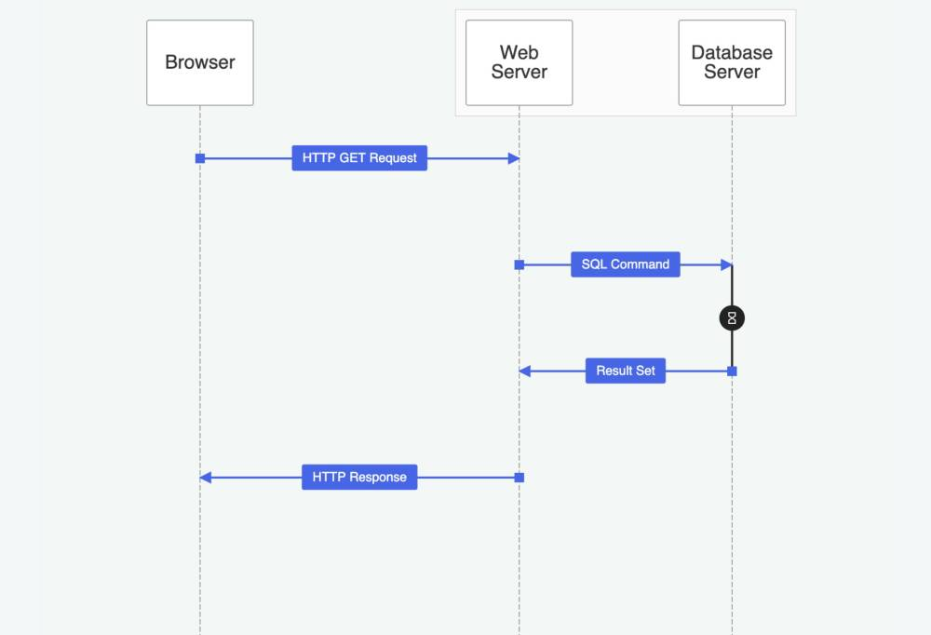
The sequence diagram illustrates the step-by-step flow of operations in the system. The process starts with the user providing the dataset in CSV or Excel format. The data is then processed in Python for cleaning and transformation. After that, the cleaned data is stored in the SQL database. The user executes SQL queries to retrieve required information, and Python is used again for further analysis and visualization. Finally, the results are presented to the user. This diagram shows the interaction between different components in a sequential manner.
Overall, the UML diagrams provide a clear understanding of how the system functions, how data is structured, and how different components interact to perform retail sales and profit analysis.

14.Outputs
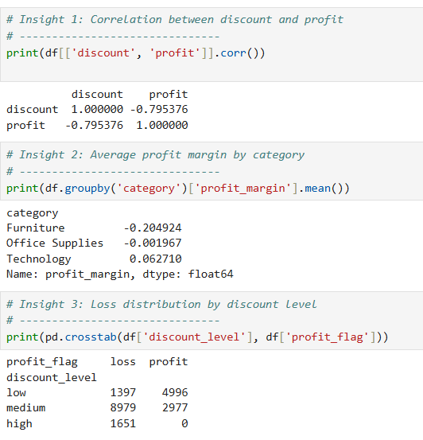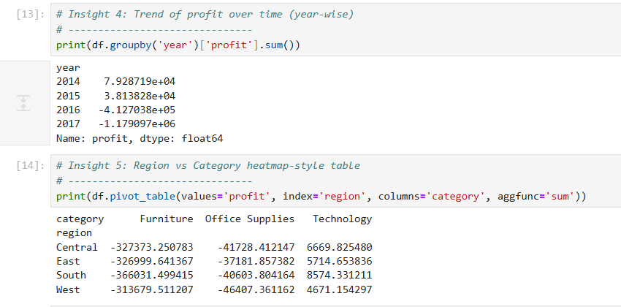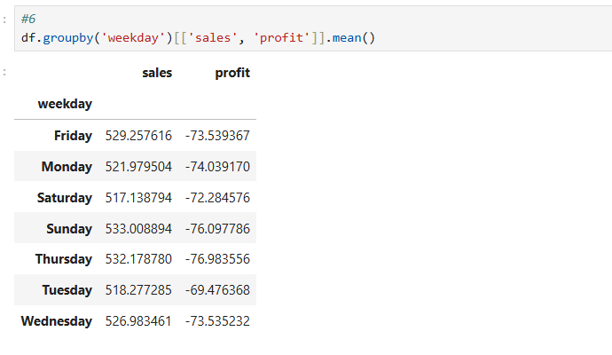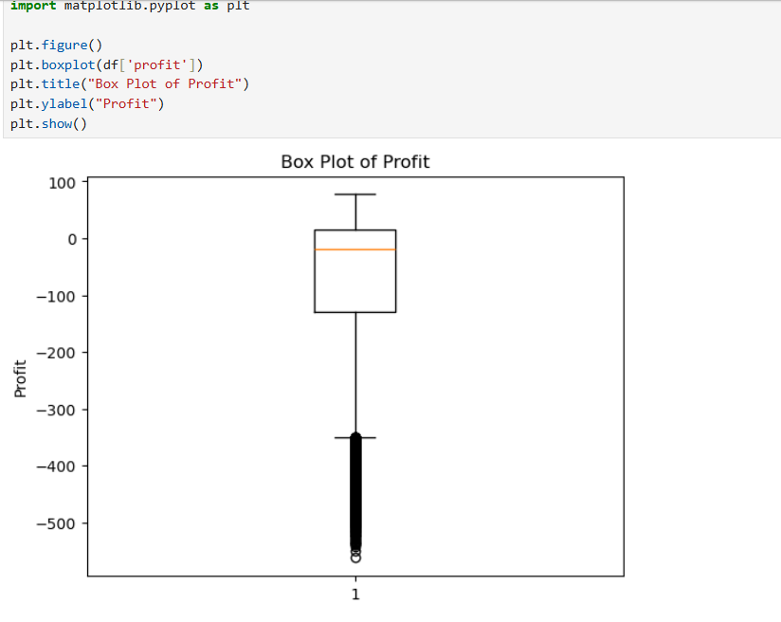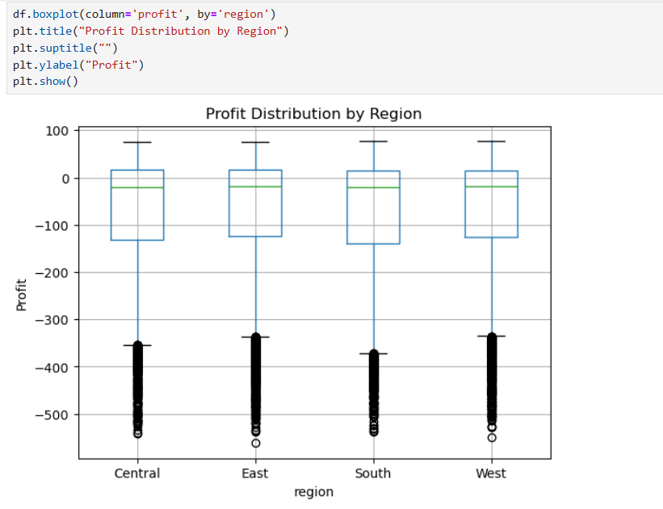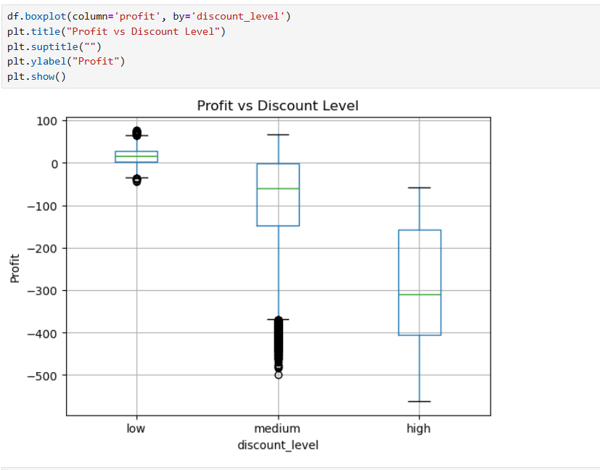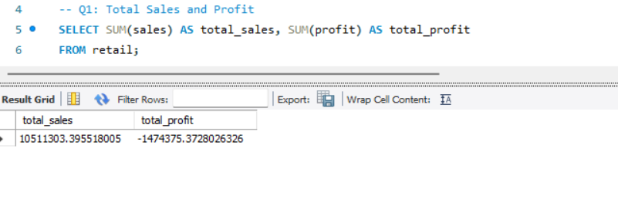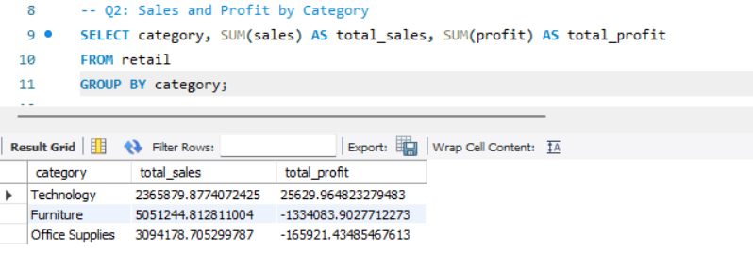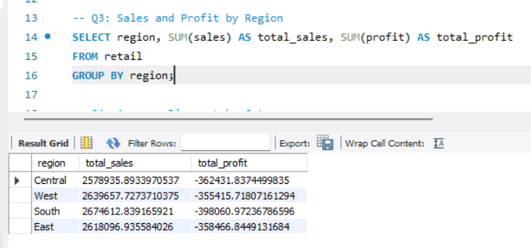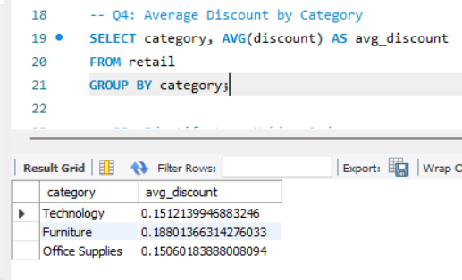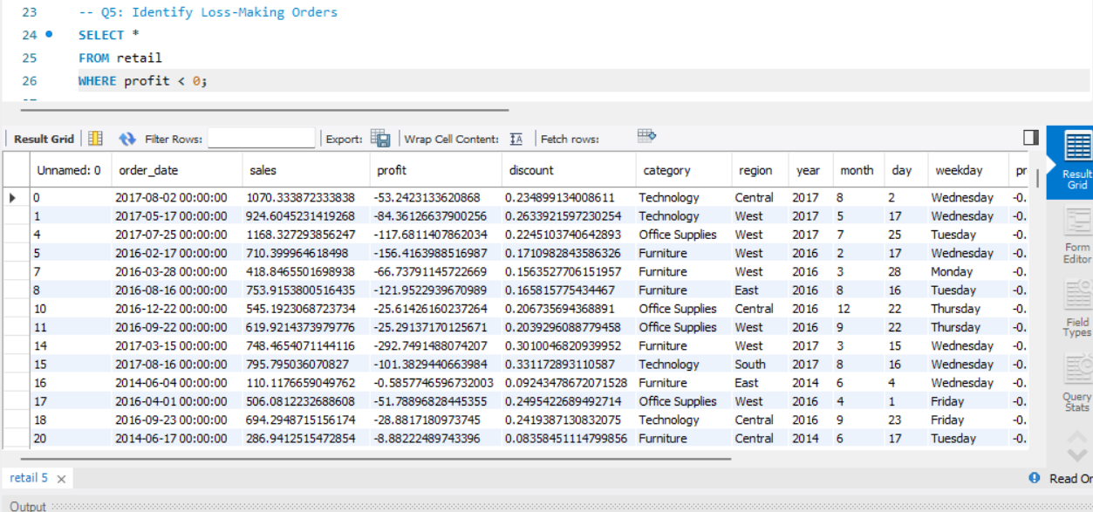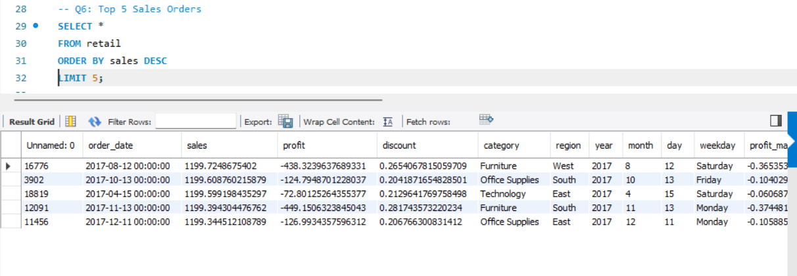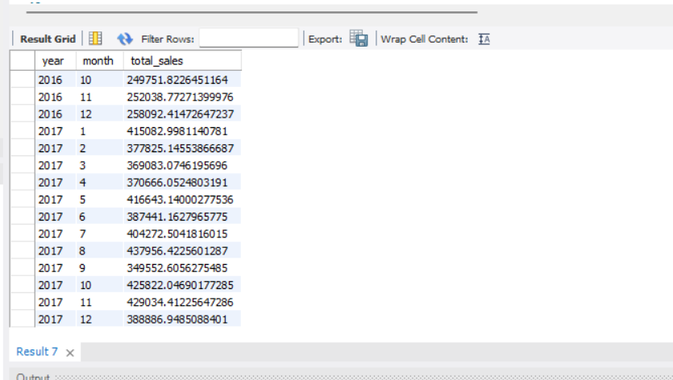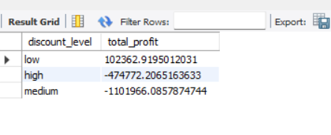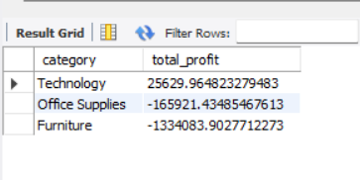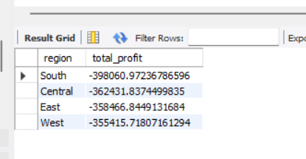
- OUTPUT AND ANALYSIS
The output and analysis section focuses on the results obtained from SQL queries performed on the retail dataset. Each query provides structured information that helps in understanding different aspects of sales and profit behavior. The following analysis is based on the generated result tables from your SQL queries .
Total Sales and Profit
This query calculates the overall sales and profit generated from the dataset. The result table shows the sum of all sales values and the sum of all profit values.
The pattern observed indicates that total sales are significantly high, but the total profit is comparatively lower. This suggests that revenue generation is strong, but profitability is not equally high.
The insight derived is that higher sales do not always lead to higher profit. This indicates the presence of factors such as discounts or low-margin products affecting profitability.
Category-wise Sales and Profit
This query groups data based on product categories and calculates total sales and profit for each category.
The result shows variation across categories, where some categories contribute more to sales but not necessarily to profit. Certain categories may show high sales but lower profit margins.
The insight is that product categories behave differently in terms of profitability. Businesses should focus on categories that provide a better balance between sales and profit.
Region-wise Sales and Profit
This query analyzes performance across different regions by calculating total sales and profit for each region.
The pattern indicates that while some regions generate higher sales, their profit levels may not be proportionally high. Additionally, some regions may show lower profit or even losses.
The insight is that regional performance is uneven, and business strategies should be tailored based on regional profitability rather than just sales volume.
Average Discount by Category
This query calculates the average discount offered for each product category.
The results show that certain categories have higher average discounts compared to others. This indicates that discount strategies vary across categories.
The insight is that higher discounts may be used to boost sales in specific categories, but they may also reduce profit margins. Careful discount planning is required.
Loss-making Transactions
This query filters all transactions where profit is negative.
The result table contains multiple records where the business incurred losses. These transactions often involve higher discount levels or lower sales values.
The insight is that loss-making transactions are present in the dataset and need to be controlled. Identifying such transactions helps in reducing unnecessary losses.
Top Sales Orders
This query retrieves the top transactions based on highest sales values.
The pattern shows that a small number of transactions contribute significantly to total sales. These are high-value orders.
The insight is that high sales orders play an important role in revenue generation, but it is important to check whether they are also profitable.
Monthly Sales Trend
This query groups data by year and month to analyze sales trends over time.
The result shows fluctuations in sales across different months, indicating seasonal or periodic trends. Some months show higher sales compared to others.
The insight is that sales are not uniform throughout the year. Businesses can use this information to plan inventory and marketing strategies based on high-demand periods.
Profit by Discount Level
This query categorizes discounts into levels such as low, medium, and high, and calculates total profit for each level.
The pattern clearly shows that low discount levels are associated with higher profit, while high discount levels lead to reduced profit or losses.
The insight is that discount strategy has a direct impact on profitability. Excessive discounts can negatively affect business performance.
Category with Highest Profit
This query identifies which product category contributes the highest total profit.
The result shows that one category stands out as the most profitable compared to others.
The insight is that focusing on high-profit categories can improve overall business performance and should be prioritized in decision-making.
Region with Highest Loss
This query identifies the region with the lowest total profit, indicating maximum loss.
The pattern shows that one or more regions contribute more to losses compared to others.
The insight is that these regions require attention, and strategies such as pricing adjustments or cost control should be implemented to improve profitability.
Overall Analysis
The combined results from all SQL queries provide a comprehensive understanding of retail business performance. The analysis highlights that while sales are strong, profitability is affected by factors such as discount levels, product categories, and regional variations. The presence of loss-making transactions and uneven profit distribution indicates the need for better pricing and operational strategies. By focusing on profitable categories, controlling discounts, and improving regional performance, the business can enhance overall profitability.
- CONCLUSION
The retail sales and profit analysis carried out in this project successfully transformed raw transactional data into meaningful insights using a structured data analytics approach. By combining SQL for query-based analysis and Python for data processing and visualization, the project was able to clearly explain how revenue is generated and why profit does not always increase proportionally with sales. The analysis helped in identifying key factors such as discount levels, product categories, regions, and time-based trends that influence overall business performance. It also highlighted the presence of loss-making transactions and demonstrated how certain strategies can negatively impact profitability.
One of the key learnings from this project is that high sales alone do not guarantee high profit. The relationship between sales and profit is influenced by multiple factors, especially discounts and product margins. It was observed that higher discount levels often lead to reduced profit or even losses, making it important to carefully design pricing strategies. Another important learning is that different product categories and regions perform differently, which means that business strategies should not be uniform across all segments. Time-based analysis also showed that sales and profit vary across different periods, indicating the importance of understanding trends and seasonality.
The project also demonstrated the importance of data preprocessing and feature engineering in improving the quality of analysis. By cleaning the data, handling missing values, and creating new features such as profit margin and discount levels, the dataset became more meaningful and easier to analyze. The use of SQL enabled efficient handling of large datasets and quick generation of summaries, while Python provided flexibility for deeper analysis and visualization.
The benefits of this analysis are significant for business decision-making. It provides clear insights into which areas of the business are performing well and which require improvement. By identifying loss-making transactions and understanding the impact of discounts, businesses can take corrective actions to improve profitability. The analysis also helps in optimizing product strategies, improving regional performance, and planning future operations based on data-driven insights.
Overall, this project highlights how data analytics can be effectively used to understand complex business scenarios and support better decision-making. The combination of structured querying and analytical processing provides a powerful approach to extracting value from data, making it highly relevant for real-world retail applications.

